1. Try giving fewer than three arguments to your script.

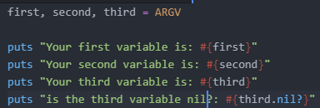

Output:





1. Write a script that has fewer arguments and one that has more. Make sure you give the unpacked variables good names.

Here is a script with two arguments:

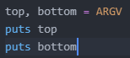

Output:



Here is my script with five arguments:

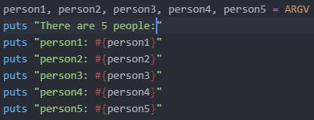

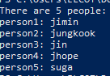

1. Change your script to use $stdin.gets.chomp everywhere that you have gets.chomp. You should use $stdin.gets.chomp from now on since the action gets.chomp has problems with ARGV.

If you simply try to put gets.chomp in the code with your ARGV, you’ll get an error

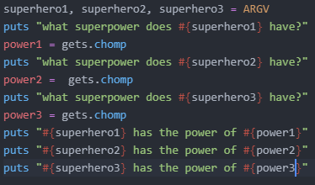

Output:

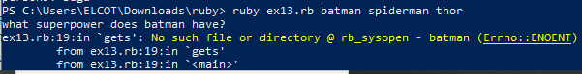

We put $stdin in front of the gets method. $stdin.gets will work. Note that $stdin is identical to STDIN by default.

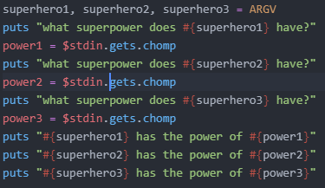

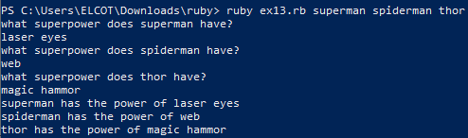

1. Now that you are using $stdin.gets.chomp (see #3) you can add ARGV to your script to get something from the user. Don't over think this. Just use ARGV to get one thing, then $stdin.gets.chomp to get something else.